Issue 1
September 2022
North Tyneside Patient Forum Newsletter
In this Issue
Covid-19 update Boosters and flu jabs
Breast cancer Support Group
Breast screening free parking
GP Practice patient groups
Anxious Minds
Can you identify this?
The Bread and Butter Thing
Cultural Diversity and Health in North Tyneside
Health Inequalities Funds
North Tyneside Carers Centre
Did You identify?
Member profile
Patient Forum Highlights

Welcome to the latest issue.

The NHS in England has changed.
It has been divided into 42 different areas called Integrated Care Systems (ICS), this is a partnership between organisations that are responsible for health and care needs across an area.

As of 1 July 2022, Clinical Commissioning groups (CCGs) ceased to exist. North Tyneside is now a part of the North East and North Cumbria ICS.

Keep up to date with latest local news
Twitter: @NHSNorthTyne
Facebook: NHS North Tyneside
Website: https://nenc-northtyneside.icb.nhs.uk/
YouTube: https://www.youtube.com/channel/UCBrlByVBprLY3x9ob3ct2nw/videos

Coronavirus (COVID-19)
For NHS information please click here
For Government guidelines please click here
For local information please click here

The Autumn 2022 vaccination programme is well underway in North Tyneside. COVID-19 and flu vaccinations are being given together where possible, if patients are happy with this. The programme started with care homes and is now rapidly opening up to other patients.

The following groups are eligible for an Autumn 2022 COVID-19 booster vaccine:
- residents in a care home for older adults and staff working in care homes for older adults
- frontline health and social care workers
- all adults aged 50 years and over
- persons aged 5 to 49 years in a clinical risk group
- persons aged 5 to 49 years who are household contacts of people with immunosuppression
- persons aged 16 to 49 years who are carers

Flu vaccine eligibility is as per usual, with the addition of healthy 50-64s but only from mid-October. In North Tyneside all GPs are offering both vaccinations, either in their practices (where you will be invited) or at central sites (Oxford Centre and North Shields Health Hub) where patients of the practices running these sites will be invited, but where all patients can also book at https://www.nhs.uk/conditions/coronavirus-covid-19/coronavirus-vaccination/book-coronavirus-vaccination/ or 119. There are also 12 community pharmacy sites offering vaccinations, all bookable as above.

Walk-in is not being offered at this time – all appointments must be booked.

Breast Cancer Support Group
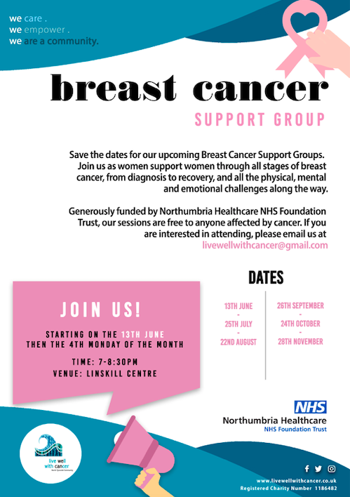

Live Well with Cancer aims to enable people live life fully with and beyond a cancer diagnosis. Our focus is to empower people through self-help, mutual support and signposting to local services. We are building a community that offers continued and flexible support to service users. We host events, deliver workshops and introduce service users to exercise regimes adaptable to all levels of fitness.
​
Live Well with Cancer is driven by a passion to help people improve their quality of life. By helping people affected by cancer, we aim to become a cornerstone of the North Tyneside community. Due to the number of people with cancer diagnoses, we are eager to work in partnership with other community services to ensure people get the care they need when they need it.

For more information visit: https://www.livewellwithcancer.co.uk/home

Breast Screening Free Parking

Did you know you can have free parking at North Tyneside General Hospital if your appointment exceeds 20 minutes. Find out more on the Living Well North Tyneside website https://www.livingwellnorthtyneside.co.uk/services/1223.pdf

GP Practice Patient Participation Group

Recruitment

Each GP practice in North Tyneside aims to have a patient group to take an active role in practice plans and developments. If this is something you would be interested in check with your practice about joining.

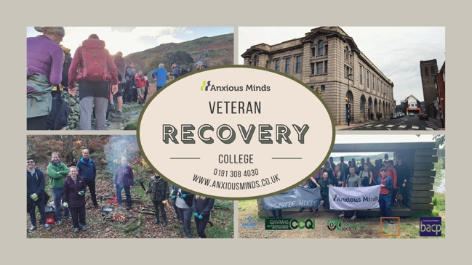
Anxious Minds

North East Mental Health Charity gets Gold and scoops three awards and is a finalist for two more for its work with Veterans and their Families.
Charity started by veteran with his War Pension and Winner of the 2021 Soldiering On Healthcare and Rehabilitation Award, Anxious Minds, is proud to announce that it has received three more illustrious award including: the Ministry of Defence’s Employer Recognition Gold Award. The following press release explains Anxious Minds work, with a quote from Edward Dean, the organisation’s Volunteer CEO.
The Defence Employer Recognition Scheme (ERS) is a Ministry of Defence run scheme which encourages employers to support the work of the Ministry of Defence and inspire others to do the same. The ERS Gold award is the highest award of the scheme, recognising organisations who actively support the Armed Forces community in their workplace. Anxious Minds, alongside 9 other organisations in the North East, was honoured to receive notification of our Gold Award 2022.
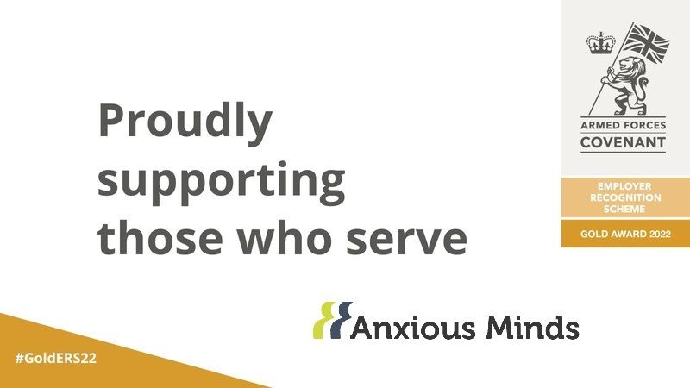
Anxious Minds has a host of company initiatives and policies in place to encourage and support service personnel in the workforce, including granting additional leave to Reservists so that they can fulfil their training requirements. Anxious Minds signed the Armed Forces Covenant in 2016 and has always had a forces-friendly environment within its workplace.
Edward Dean, the Volunteer Chief Executive Officer of Anxious Minds a veteran of 22 years’ service said: “It was fantastic news to hear that Anxious Minds has won another award for its work with veterans and their families. The Gold Award, under the Employers Recognition Scheme run by the MOD as part of the Covenant.”
“We are delighted with this award, it coincides with the other three National awards we have won for our work with the veteran community over the last 12 months and highlights the support that we have given to veterans and their families, reservists and a number of people that we employ within our staff and is a real recognition of the work our veterans team do across the Armed Forces Community.”
Awards Anxious Minds has won for veteran work.
- ERS Gold Award
- Best Veteran Focused Mental Health Service - North East England GHP Mental Health Awards 2022
- Best Vulnerable People Support Provider North East England Healthcare & Pharmaceutical Awards 2021
- Soldiering on Award 2021 (Healthcare and Rehabilitation)
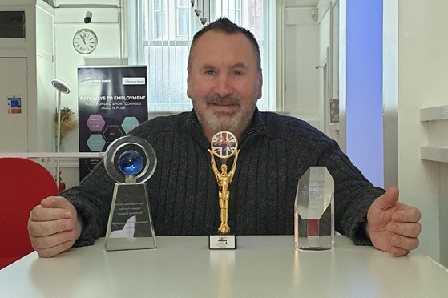
Anxious Minds Veteran Families Recovery College provides the following services for veterans and their families. All services are in-house from the college, we don’t signpost unless there is a need and we cannot provide the support by our partners. Our Aim is to improve the support veterans and their families receive in the North East.
- Counselling
- Addiction Support
- Outdoor Therapy
- Fitness Classes
- Breakfast Club
- Food Bank
- Welfare Support

The Veteran Recovery College – Wallsend North Tyneside
0191 308 4030
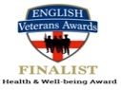
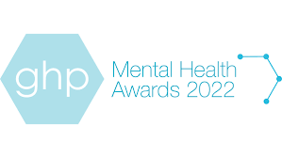
We are helping to build a better support network for our Armed Forces Community, highlighting a united commitment to our Armed Forces Covenant.

Can you identify this local landmark?

Find the answer on page 8

The Bread and Butter Thing
The Bread and Butter Thing (TBBT) is one of the UK’s leading community food organisations and has brought its innovative and affordable food service to North Tyneside in partnership with North Tyneside Council.

Find out more from their website https://www.breadandbutterthing.org/

This is the video explaining the scheme which was first run from Howdon Hub earlier this year
https://m.facebook.com/watch/?v=550895199593708&_rdr

This is the article on the first launch of the scheme across North Tyneside
https://my.northtyneside.gov.uk/news/29808/award-winning-affordable-food-scheme-launches-first-north-tyneside-hub-howdon

Locations can now be found at the following;
- Longbenton Community Centre – Tuesday 2 – 2:30pm
- Shiremoor Adventure Playground Wednesday 1:30 – 2pm
- Howdon Community Hub Friday 1:30 – 2pm

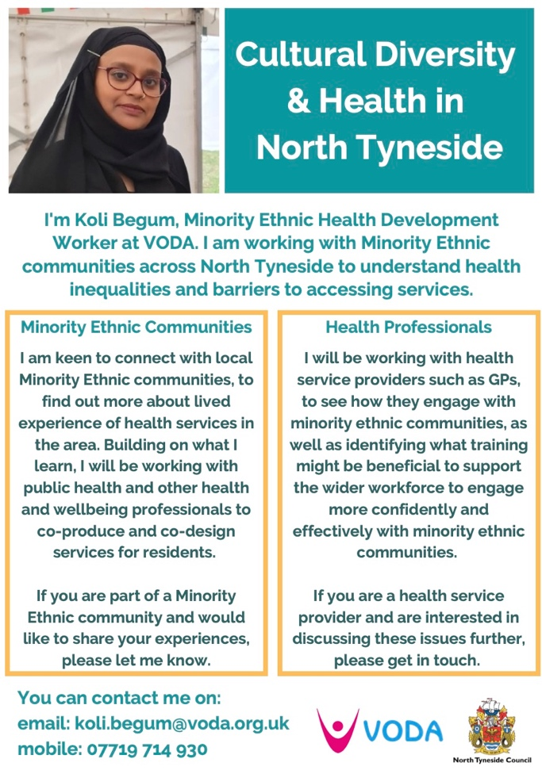
Cultural Diversity and Health in North Tyneside

VODA recently welcomed Koli Begum to their staff team as the Minority Ethnic Health Development Worker. Koli is working with Minority Ethnic communities across North Tyneside to understand health inequalities and barriers to accessing services.
Koli is keen to connect with local Minority Ethnic communities and health professionals to find out more about access to services and health inequalities in our area. If you would like to discuss these issues further with her, please get in touch.
You can contact Koli via koli.begum@voda.org.uk or
call 07719 714 930. Koli will also be sharing relevant content on the Cultural Diversity & Health North

Health Inequalities Fund
Support and Grow have set up five Cuppa Clubs with their successful funding application.
Cuppa Club at Lovaine Community Gardens - This is a tranquil venue with the option of gardening or simply sitting and enjoying the sensory garden. The strategy behind this Cuppa Club was to provide a stress -free venue for those suffering mental health issues or trauma.
A trained SGNE volunteer is in attendance to offer access to our wider services. The focus of this club is to improve mental health. We have been receiving referrals from the mental health enablement team.

Cuppa Club at Backworth Club - This is a more family friendly venue and attracts mums, grandparents and adults with disabilities who live locally. We have clients who were referred from the mental health enablement team who like this venue too. It is more upbeat, and there are usually family activities that the attendees can engage in. The club provides hot nutritious food at low prices, which attracts those that struggle to cook at home. Many have been engaging in group walks after the club, facilitated by our volunteers. We are looking to introduce indoor fun physical activities over the winter.

Special Educational Needs and Disability (SEND) Cuppa Club at the Tim Lamb Centre - This is our Cuppa Club for our families who have children with SEND and their siblings. Families living in poverty, who also live with disabilities experience greater health inequalities. They are often isolated as they are unable to engage in mainstream family activities due to the additional needs of their disabled child. This causes mental health challenges for the parents and siblings, as well as the child with SEND. The cost of SEND specific activities and the lack of affordable childcare for siblings further excludes these families. Families were also reporting a lack of emotional support. We are especially proud of our SEND Cuppa at the Tim Lamb Centre as this allows our most vulnerable families to engage in physical and social activities without judgement and we meet the cost. They also have peer support, and access to our services via our SEND volunteer who is also a parent carer. We have since set up a peer support SEND Facebook group.

Cuppa Club Crafts with our Ukrainian Guests, at St Peters Church, Monkseaton - This Cuppa Club incorporates trauma informed craft activities, access to our support services, a Ukrainian Interpreter, access to our English conversation classes and access to community engagement and volunteering opportunities. Some of our Ukrainian guests have since become Support and Grow Volunteers! This group is frequented by local residents too, including the elderly and some referrals from the mental health enablement team. The result of this has been visible increased mental and physical health and greater community cohesion and understanding. Many have connected outside of the cuppa club to enjoy walks along the coast and the fish quay.

Warm Hub Cuppa Club - We plan to launch this Cuppa Club in September from our base at Bertram Grange Community Centre. We have recently taken over management of this community centre in the most deprived part of Shiremoor. We plan to make it a warm hub, which will include hot food, free activities for physical and mental health, and access to our wider services.. We will also have a social supermarket. We are mindful of the food and fuel crisis, and the impact the winter will have on the physical and mental health of the most vulnerable. This Cuppa Club will include key guests to advise on issues around staying healthy and managing financially during the food and fuel crisis.

North Tyneside Carers Centre
Being a carer can be tough and one source of comfort and practical help that has stayed the test of time is the support group. At the North Tyneside Carers’ Centre there are currently 5 groups that meet regularly, and we want to introduce them to you. They could change your life!

Carers Peer Support Group for all Carers This is a support group for carers of people with any condition. They meet regularly to talk and share advice and information and also to make new friends. All carers are welcome. Our face-to-face group meets on the first Tuesday of each month, 2.30pm-4pm in the Scout HQ, Norfolk Street, North Shields, NE30 1NQ. The online group meets the 3rd Tuesday of the month, 2.30pm-4pm. Don’t hesitate to get in touch and we will provide further details.

Autism Carers' Group
This group is for carers of people with Autism. They support each other, sharing news, advice and friendships. The next face to face group will meet on Thursday 20th October 22, 6pm-8pm in the Scout HQ, Norfolk Street, North Shields, NE30 1NQ, followed by alternate months. The online group will be meeting on Thursday 17th November, 6pm-7.30pm followed by alternate months.

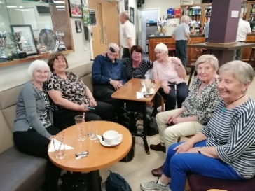
Bereaved Carers' Group
Are you a bereaved carer who has lost the person they care for, why not join the carer group who support each other at any stage of bereavement. The members of the group also organise social activities amongst themselves independent to the Centre group. They meet on the last Thursday of the month from 11am-12pm in Whitley Bay Comrades Club, The Links, NE26 1PS.
If you have not attended before please ring 0191 6432298 for more details.

Mental Health Carers' Peer Support Group
This group meets face to face at Linskill Centre, North Shields, NE30 2AY between 6pm-8pm on the last Thursday of each month. The group is for carers of people with mental health issues. Find support and information from people who have experienced similar situations as you. To attend for the first time ring 0191 6432298 for more details.

The Dementia Support Group
For carers of someone who has dementia, the group meets monthly and new members are always welcome. It's a great opportunity to share with people experiencing the same situations as you are. The Group meets on the 2nd Tuesday of each month from 10.30am-12pm with alternative sessions online and face to face at the White Swan Centre, Killingworth, NE12 6SS. Please ring the carers centre on 0191 6432298 to attend your first meeting or turn up as our group leaders will welcome you. As always, if you need to get in touch to make comments, or need information, advice or support you can phone the advice line: 0191 643 2298 or by email enquiries@ ntcarers.co.uk

Would you like to work with the North Tyneside Carers’ Centre Team?
We are currently looking to expand our team of staff to support Carers in North Tyneside.

The jobs available are currently:
- Wellbeing Worker (Mental Health) with the Adult Carers Team
- Carers Information and Advice Worker with the Adult Carers Team
- Young Carers Activities Worker
If you would like further information, please call the centre on 0191 643 2298

Did you identify this?

Answer: Tynemouth Priory featuring Collingwood Monument
Thank you to Sam Stephenson for the image.

Member Profile

Hi, my name is Maureen Doolan, first and foremost I am a patient and user of both primary and secondary NHS services and I also have a disability. I got involved with the Patient Forum because I wanted to make a difference.

I worked for the NHS for 20 years in a variety of roles from a Support Worker in the Xray department to a Community Development Worker and co-ordinator of the Community Mothers Programme a project that promoted the health and wellbeing of parents and children, I was a Mental Health First Aid trainer for the NHS and I also delivered training to staff working with people from the BME communities which looked at challenging prejudices and tackling inequalities. I have had a lot of experience in setting up projects that promote mental health and well-being and have been involved in the past with tackling inequalities and barriers to accessing heath care services.

Although I am now on the other side and a user of NHS services, I am still passionate and committed to principles which promote and improve the health and wellbeing of not just my family and friends but the wider community in North Tyneside and beyond. Being a part of the forum enables me to do that by getting involved with the working groups. I feel it’s important to speak up for those who feel they don’t have a voice in the community.

I like meeting new people and although I’ve had some challenges in my life I try to stay positive and have a desire to enable and help others.

North Tyneside Patient Forum highlights
Members are involved in a range of working groups; Innovations, which recently received information and visited the new North Shields Health Hub offering a range of community services. Members are also working on the content of a health and wellbeing booklet. Communications, as well as producing this newsletter members are reviewing Talking Therapies patient letters. Future Care, North Tyneside’s Equally Well Strategy has been discussed and responded to by members.

This newsletter has been produced quarterly by members of the North Tyneside Patient Forum Communications Working Group.

If you like the sound of the Patient Forum and would be interested in being part of it please contact; Michele Spencer michele@chcfnorthtyneside.org.uk for more information.

